Attachment 1
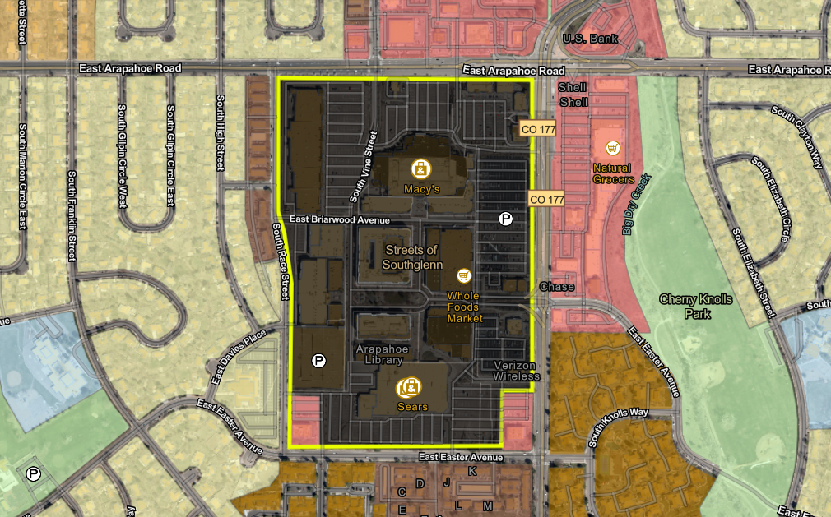
Existing Zoning Map – PUD-21-00004
S. Race St.
E. Easter Ave.
S. University Blvd.
E. Arapahoe Rd.
NC₁₂
ED
ED
AC
NCSFA
NCSFA
NCMF
NC₉
NC₉
NC₉
NC₉
NCMF
OSR
OSR
AC
AC
AC
AC
PUD

