# 

# Centennial Economic Activity

## Company Announcements

* Jordon Perlmutter & Co. purchased 21.95 acres of land at Lincoln Executive Center in Centennial for development of approximately 300,000 square feet of industrial space that will feature 24-foot clear height and front-park, rear-load design. The speculative development is planned to include four high-image buildings that will likely be built in two phases. The company likely will break ground on the first two buildings in the first quarter of 2020.
* Brown Brothers Harriman and Co., a New York City-based investment bank and financial advisory firm, will shut down its Centennial office at 6801 S Tucson Way. All 136 employees will lose their jobs between November 25 and September 30 of next year. The firm employs more than 6,000 people across 18 offices. Positions being cut include operations specialists and analysts, fund accountants, and legal analysts.

## Rankings and Economic Headlines

* Thumbtack, a San Francisco-based company, ranked Denver No. 6 in the company’s “2019 Small Business Friendliness Survey”. The report surveyed over 5,000 small business owners, asking questions such as licensing requirements, tax regulations, and labor and hiring regulations. Denver received an “A” mark, with high ratings for employment, labor and hiring, government websites, ease of hiring, and training and networking programs. In 2018, Denver earned a C- ranking, with an F for government websites. Overall, the state of Colorado received an A- score, up from a C- overall in 2018.
* According to CBRE’s annual “Scoring Tech Talent” report, Denver ranked No. 8 for best market for tech talent, moving up two spots from last year. The report analyzed 13 metrics including tech talent supply, growth, concentration, cost, completed tech degrees, industry outlook for job growth, and market outlook for both office and apartment rental growth. Greater Denver had the 13th-largest tech talent market and the fifth-highest market for educational attainment.
* In the “Emerging Trends in Real Estate” report by the Urban Land Institute, Denver ranked No. 17 for overall real estate prospects. The report surveyed respondents and asked them questions about national and local real estate prospects, how investors are allocating their transactions, and how the flow of people shape the area. Denver ranked No. 8 last year, falling 11 spots this year. The report noted Denver had a strong growth trajectory combined with a good size but had hurtles to overcome such as rising costs in residential real estate and construction.
* According to HSH.com’s “Home Price Recovery Index”, Metro Denver ranked first for areas that have recovered the most from the previous peak of housing prices. The report uses the Federal Housing Finance Agency’s (FHFA) Home Price Index to determine which housing markets have recovered using peak values reached before and after the recession. Metro Denver home prices were 91 percent higher compared with the previous peak before the recession, the largest movement in housing prices.
* According to CNBC’s “America’s Top States for Business” study, Colorado ranked No. 9. The study ranked all states for business competitiveness using more than 60 metrics across 10 categories, including Workforce, Economy, Quality of Life, and Cost of Doing Business. Colorado achieved 1,486 out of 2,500 points. Top qualifications for the ranking included Colorado’s economic growth in 2018 (+3.5 percent), low unemployment (3.2 percent), and the state ranking No. 7 in both Quality of Life and Technology & Innovation. Worst categories for the state included Cost of Doing Business (No. 37), Infrastructure (No. 35), and Cost of Living (No. 34). Virginia, Texas, and North Carolina placed first, second, and third, respectively.

# Employment Activity

## Total Employment

* During the first quarter of 2019, companies in Centennial employed 64,171 workers across 5,020 businesses, an increase of 1.6 percent compared with employment in the first quarter of 2018. Employment in Metro Denver[1] reached over 1.65 million people during the period, a 2.1 percent increase over-the-year.
* The professional and business services supersector employed the most people in Centennial at 16,402 employees, followed by financial activities (7,745 jobs) and education and health services (6,752 jobs).[2] Similarly, professional and business services employed the most people in Metro Denver, with 306,687 jobs in the first quarter of 2019.
* Seven of the 13 supersectors reported growth over-the-year, with mining and logging reporting the largest increase (+75.1 percent), followed by construction (+7.4 percent), and professional and business services (+5.3 percent). Professional and business services added the most jobs over-the-year, increasing by 829 employees. The information supersector reported the largest decrease in employment, falling by 2.9 percent, or by 115 fewer jobs, over-the-year, followed by financial activities (-2.4 percent) and education and health services (-2.3 percent). There was a net increase of 1,032 jobs during the period across all supersectors in Centennial. In Metro Denver, all 13 supersectors reported over-the-year increases, adding 34,786 jobs during the period. Similar to Centennial, mining and logging reported the largest increase of 8.8 percent, adding 1,199 jobs.

## Average Wage

* 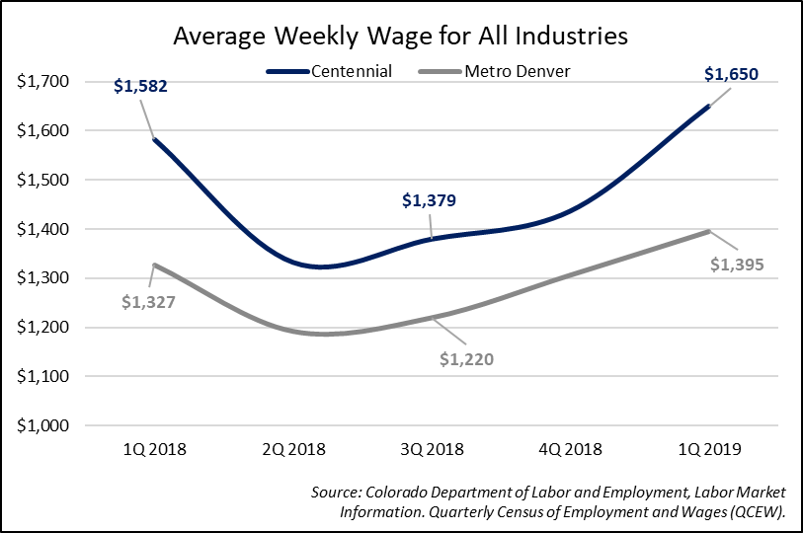The average weekly wage in Centennial for all industries was 18.2 percent higher than the average weekly wage in Metro Denver, representing an additional $254 per week.
* The mining and logging supersector reported the highest weekly wage at $2,962 per week, a 30.1 percent decrease from the same time last year which totaled $4,236 per week.
* Ten of the 13 supersectors in Centennial reported increases in the average weekly wage between the first quarters of 2018 and 2019. The information supersector reported the largest increase, rising by 20 percent to a weekly wage of $2,767. This large increase was due to a high-valued company entering the data series with a marginal addition of employees to the area. Mining and logging reported the largest decrease over-the-year (-30.1 percent), followed by construction, which fell 5.7 percent. Leisure and hospitality reported the lowest weekly wage at $435 per week.

## Business Counts

* Centennial added 38 businesses over-the-year to a total of 5,020 businesses.
* The professional and business services supersector reported the highest business count in Centennial of 1,563, growing by just one company over-the-year. Financial activities reported 779 businesses, growing by 15 over-the-year, followed by education and health services which reported 567 businesses during the first quarter of 2019.
* Eight of the 13 supersectors reported growth in business count over-the-year, with the information supersector reporting the largest percentage increase of 8.1 percent (10 businesses), followed by construction (+2.8 percent) and financial activities (+2 percent).
* Mining and logging contracted by 7 businesses, or 21.2 percent over-the-year, followed by retail trade (-2.5 percent) and leisure and hospitality (-1.1 percent). The utilities and government supersectors both reported no change in business count over the period.

# Centennial High Location Quotient Employment Activity

The location quotient (LQ) is a ratio that compares the region's employment share of a particular industry with the employment share nationwide. LQ’s were computed for three-digit North American Industry Classification System (NAICS) subsector level codes. Subsectors with a LQ of 1.5 or greater are highlighted below.

## Total Employment – High LQ’s

* Of Centennial’s total employment, 45.5 percent of the workers are in the identified 12 high location quotient subsectors.
* Professional, scientific, and technical services reported the largest absolute increase, adding 419 people at a rate of 5.1 percent. Merchant wholesalers, durable goods added 141 jobs (+3.1 percent), followed by data processing, hosting, and related services that added 100 jobs, an increase of 20 percent over-the-year and the largest percentage increase across subsectors.
* Employment in seven of the 12 subsectors contracted over-the-year, with the largest decreases in lessors of nonfinancial intangible assets (-34.6 percent), credit intermediation and related activities (-8.2 percent), and telecommunications (-6 percent). Overall, employment increased by 296 jobs across all subsectors.

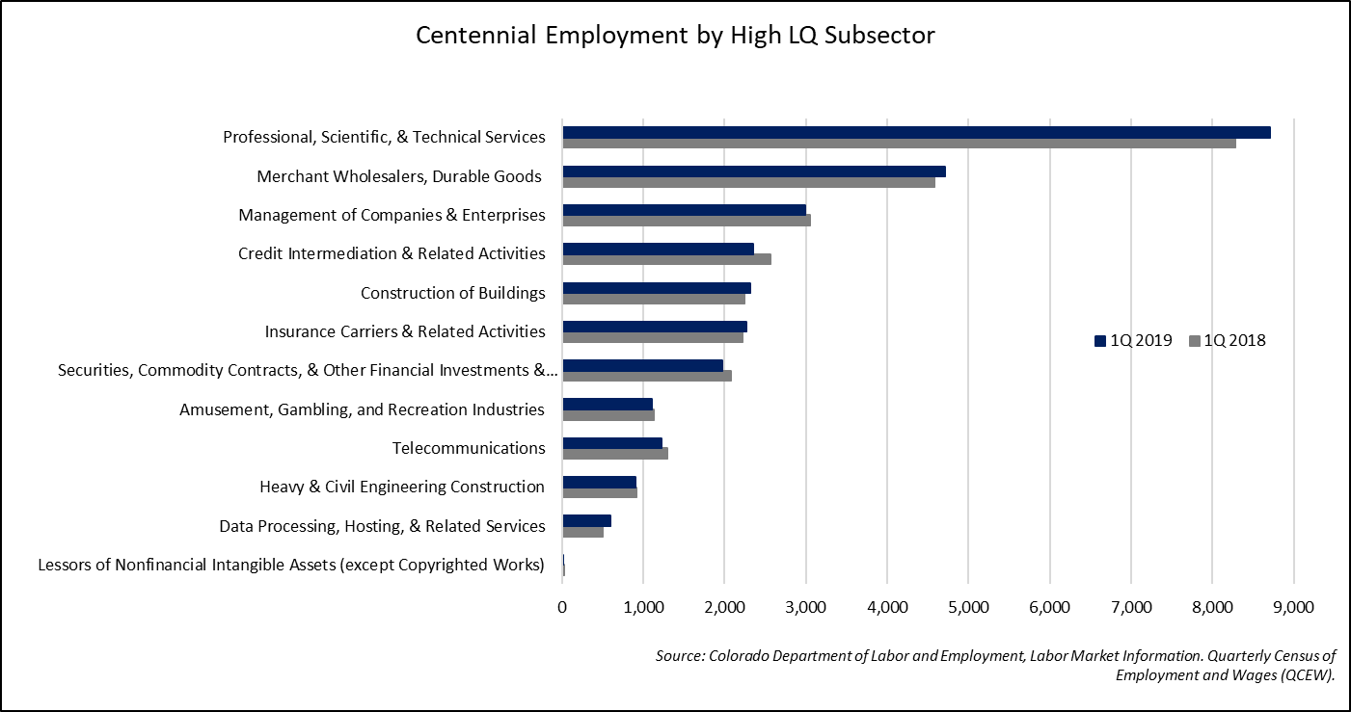

## Average Wage – High LQ’s

* Nine of the 12 subsectors in Centennial recorded growth in the average weekly wage between the first quarters of 2018 and 2019. Data processing, hosting, and related services reported the largest percentage and absolute increase, rising by 52.9 percent, or $2,167, over-the-year. The large increase was due to a high-valued company that entered the data series, bringing up the weekly wage across the subsector.
* Construction of buildings, and heavy and civil engineering construction reported the largest over-the-year decreases, falling 7.6 percent (-$166 per week) and 5.3 percent (-$81 per week), respectively.
* The amusement, gambling, and recreation industries reported the lowest weekly wage at $468 per week, while the data processing, hosting, and related services subsector reported the highest weekly wage at $6,263 per week.

## Business Counts – High LQ’s

* The professional, scientific, and technical services subsector had the highest business count in Centennial at 1,144 businesses. This was a 0.9 percent increase over-the-year, representing an additional 10 businesses during the period.
* Seven of the 12 subsectors reported increases in business count, with data processing, hosting and related services reporting the largest percentage increase at 28.6 percent growth, followed by construction of buildings (+8.5 percent) and merchant wholesalers, durable goods (+5.2 percent), which also had the largest absolute increase of 13 additional businesses during the period. Telecommunications fell 4.8 percent, decreasing by 1 business to 20 throughout Centennial, followed by insurance carriers and related activities that fell 3.2 percent, or by 7 businesses, during the period.

## Analysis – High LQ’s

Bubble charts are popular tools used to illustrate industry clusters. These charts allow multiple variables to be plotted within the same graph, making it easy to assess relative economic performance. Bubble charts are often used for pinpointing priority industries since they allow visual comparisons of economic measures.

This chart illustrates industry cluster relationships for the 12 high location quotient subsectors. The following four variables are plotted:

* One-year direct employment growth, 1Q 2018 to 1Q 2019, on the x-axis (horizontal);
* The industry’s location quotient on the y-axis (vertical);
* Employment size of the industry, 1Q 2019; indicated by the size of the bubble;
* Subsectors that are included in the same supersector are the same color.

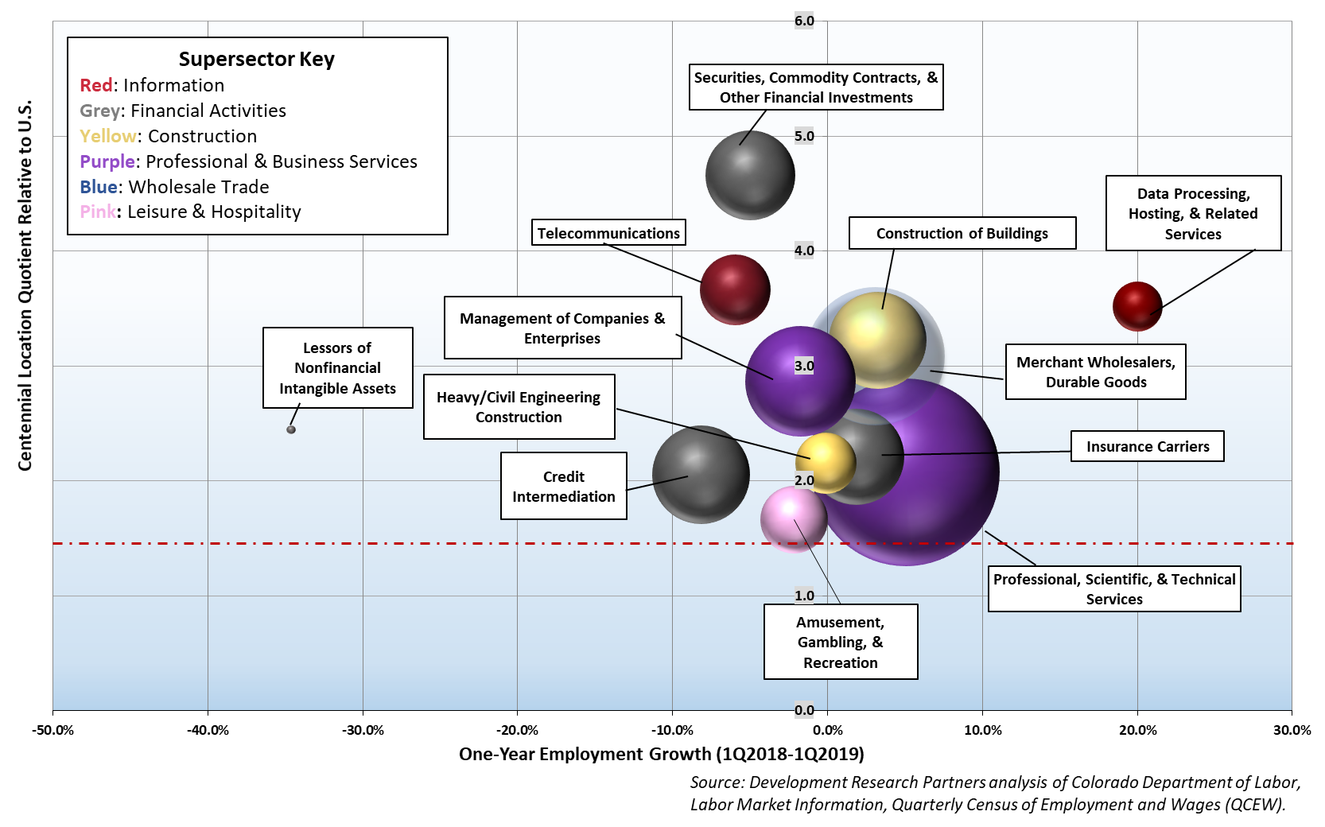

The dotted red line on the graph represents the location quotient equal to 1.5 to easily identify the bubbles that are above this demarcation.

# Labor Force

## Unemployment Rate

* 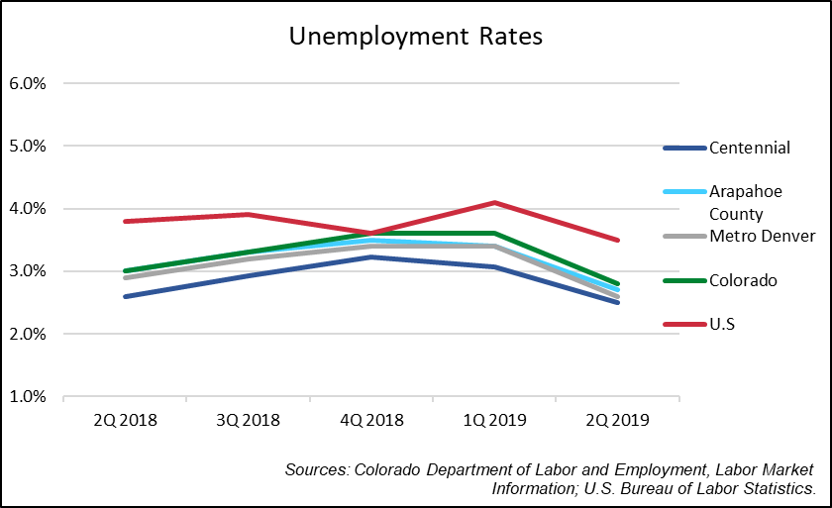The labor force in Centennial rose 1.8 percent between the second quarters of 2018 and 2019, adding 1,154 people to the labor force. Arapahoe County reported a 1.6 percent increase over-the-year, while Metro Denver increased 1.7 percent, adding 31,062 people to the labor force over-the-year.
* The unemployment rate in Centennial fell 0.1 percentage points over-the-year to 2.5 percent and down 0.6 percentage points from the previous quarter. Arapahoe County reported an unemployment rate of 2.7 percent, down 0.3 percentage points from the same time last year. Unemployment in Metro Denver fell 0.3 percentage points to 2.6 percent, while Colorado unemployment fell 0.2 percentage points to 2.8 percent. Nationally, unemployment fell 0.3 percentage points over-the-year to 3.5 percent unemployment.
* Centennial residents represented 17.7 percent of the total labor force in Arapahoe County during the second quarter of 2019.

# Consumer Activity

## Consumer Confidence Index

* 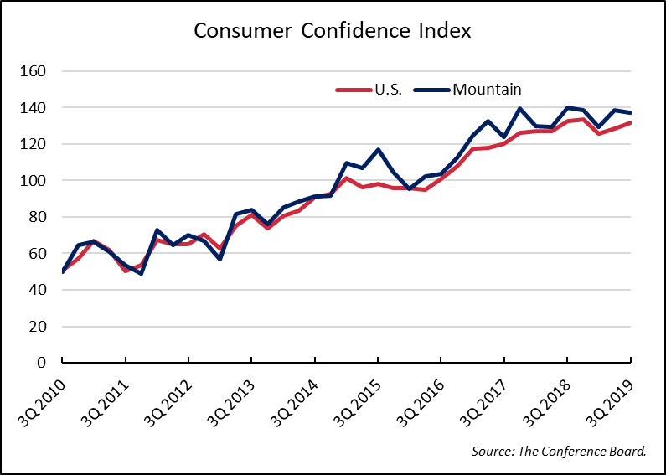The Conference Board’s National Consumer Confidence Index decreased during the third quarter of 2019, falling by 0.7 percent over-the-year to 131.7. Between the second and third quarter of 2019, the national index rose 2.7 percent. According to analysts, the escalation in trade and tariff tensions appeared to have rattled consumers in late August, however strong labor market conditions have continued to drive consumer spending amidst uncertainty.
* Colorado is included in the Mountain Region Index and the area reported a decrease of 1 percent between the second and third quarter of 2019. The Mountain Index also reported a 1.8 percent decrease over-the-year.

## Local Net Taxable Sales

* Net taxable sales increased 3.4 percent between the second quarter of 2018 and the second quarter of 2019, recording $404.1 million in net taxable sales.
* 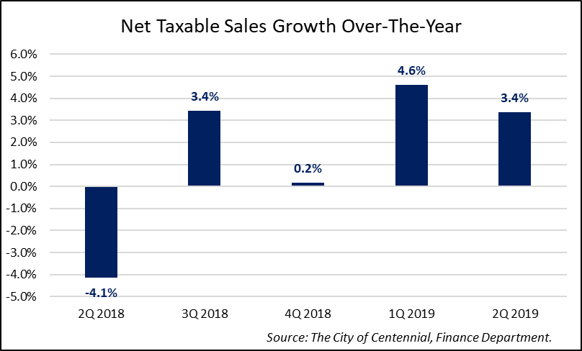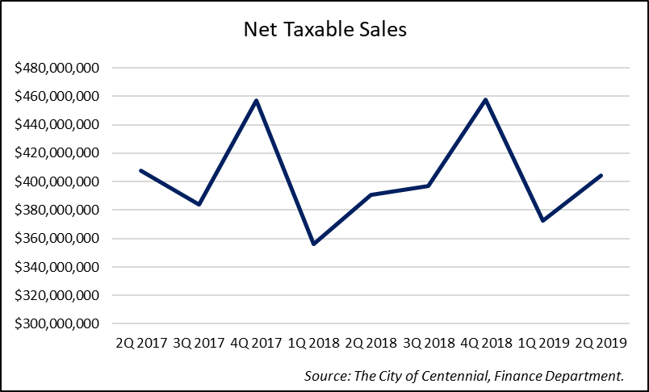Net taxable sales increased 8.4 percent over-the-quarter, rising from $372.7 million in the first quarter of 2018.

## Median Household Income

* 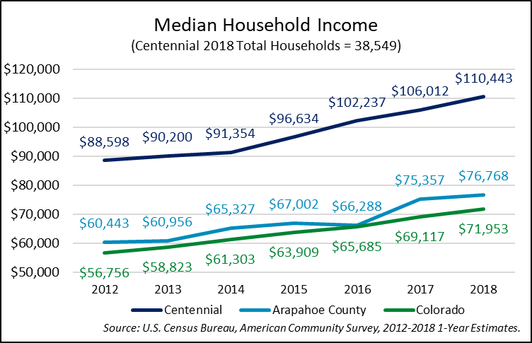Median household income for Centennial increased 4.2 percent between 2017 and 2018, representing an additional $4,431 a year. The number of households in Centennial decreased during the period, falling 4.8 percent, or by 1,931 fewer households.
* Median household income rose 24.7 percent from 2012 to 2018, while the number of households increased by 2.9 percent during the same period.
* 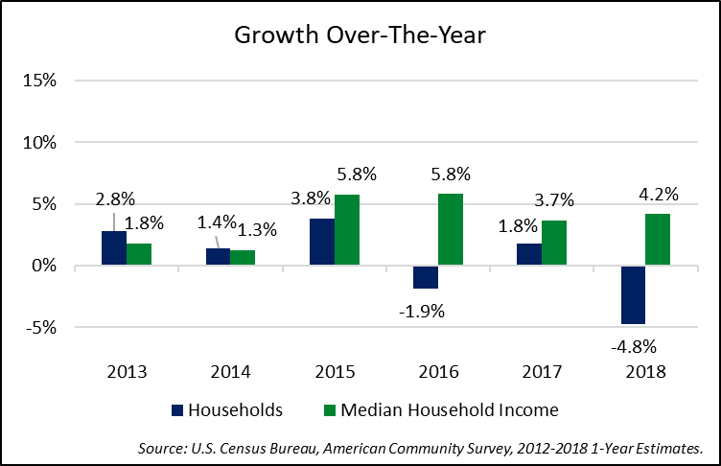The consumer price index increased 16.6 percent from 2012 to 2018, so the inflation-adjusted increase in median household income was 8 percent.

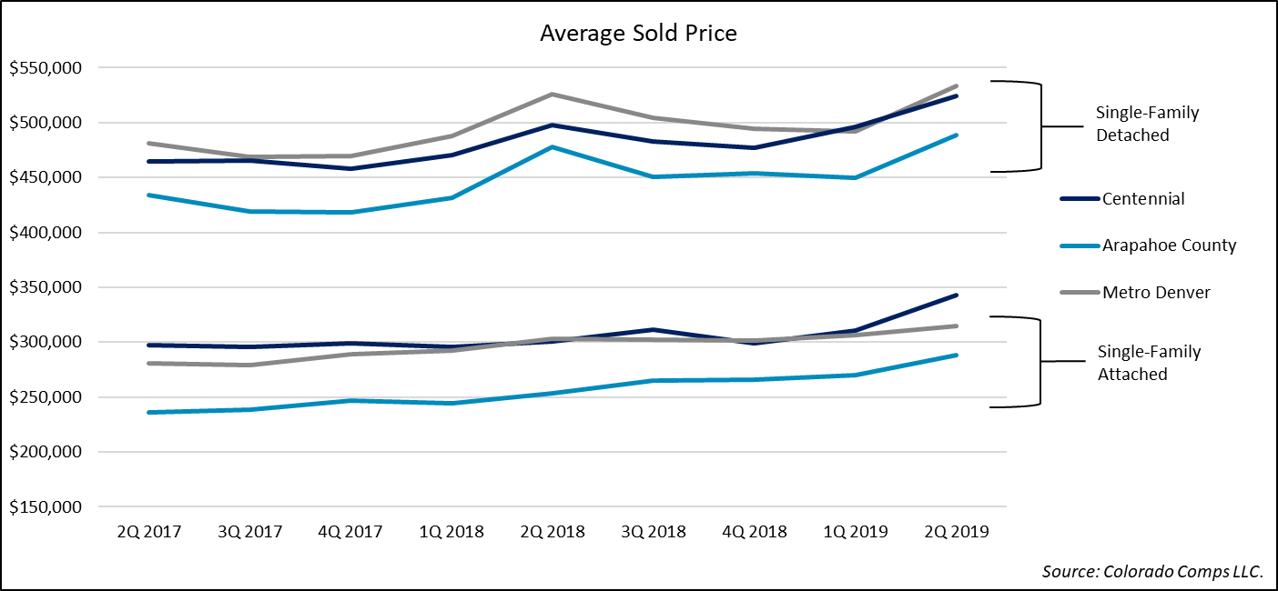Residential Real Estate

## Existing Home Sales

* The housing market in Centennial reported continued growth in the second quarter of 2019, with home sales increasing 2.1 percent for the single-family detached market and home sales remaining flat in the single-family attached market in Centennial over-the-year. The attached market in Arapahoe County increased 9.7 percent over-the-year to 1,201 homes sold in the second quarter of 2019. Metro Denver reported 27 fewer attached homes sold, a decrease of 0.7 percent during the period.
* Centennial reported an appreciation of 14.2 percent in attached home prices over-the-year to an average sales price of $342,888. Arapahoe County prices rose 13.5 percent, rising by $34,326 to an average price of $287,875, while Metro Denver reported an increase of 3.6 percent to an average price of $314,539.
* The attached home price in Centennial of $252 per square foot is higher than Arapahoe County ($234), but lower than Metro Denver ($268).
* Home sales for single-family detached homes increased in all three market areas, with a 2.1 percent increase in Centennial, a 10.8 percent increase in Arapahoe County, and a 2.4 percent increase in Metro Denver. Home sales in Arapahoe County grew by 243 homes over-the-year, totaling 2,496 single-family detached home sales.
* Sales prices for single-family detached homes rose across all three market areas between the second quarters of 2018 and 2019. Home prices in Centennial increased 5.4 percent, or by $26,846, to an average price of $524,493. Arapahoe County reported a 2.3 percent increase in detached prices to $488,723. Metro Denver reported a 1.4 percent increase over-the-year, rising to $533,063.
* The price per square foot of single-family detached homes in Centennial increased 2.3 percent over-the-year, rising at a faster rate than both Arapahoe County (-0.1 percent) and Metro Denver (+1.1 percent).

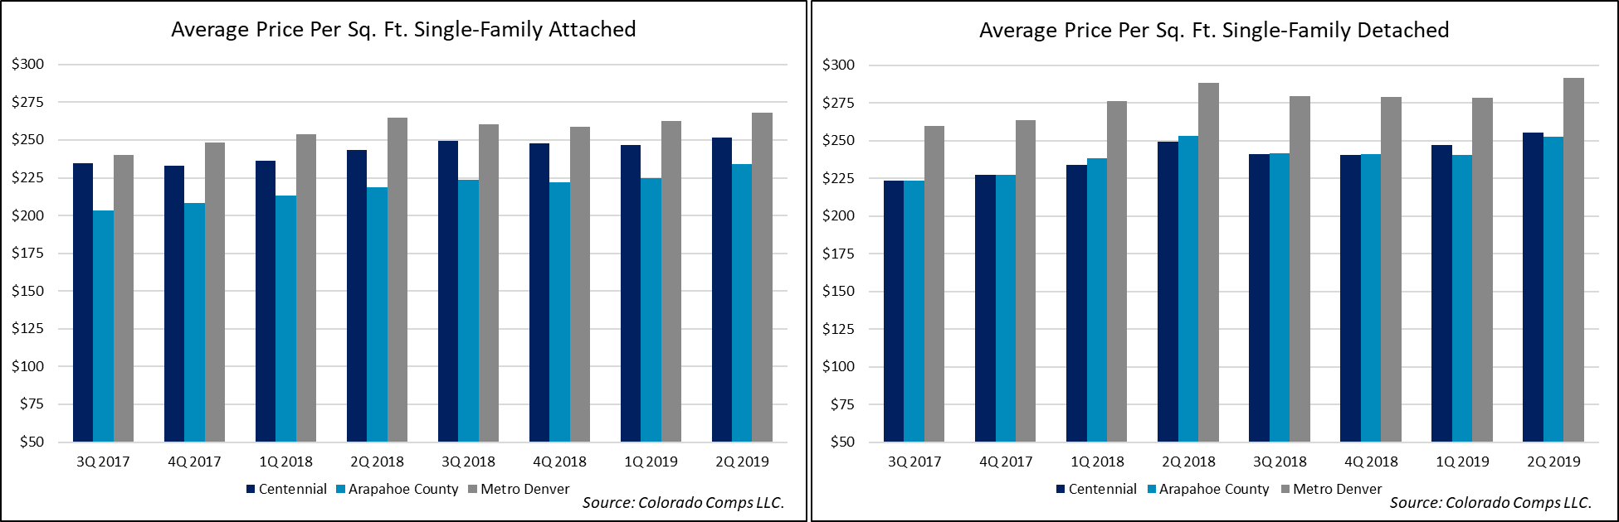

## Apartment Market



* Apartment vacancy rates decreased in all three market areas between the second quarters of 2018 and 2019. The Arapahoe County-South[3] market reported a decrease of 7.2 percentage points over-the-year to 9 percent vacancy. The vacancy rate in Arapahoe County-South was influenced by new units leasing up during the period. The Arapahoe County-Southeast[4] decreased 1.3 percentage points to 3.4 percent, while the Metro Denver vacancy rate decreased 1 percentage point to 5 percent during the period.
* The average rental rate for all property types increased in two of the three markets over-the-year. Arapahoe County-Southeast reported the largest increase, rising 4.2 percent, while Metro Denver rose 2.4 percent. The Arapahoe County-South market reported a decrease of 0.5 percent over-the-year.

## New Residential Building Permits

* New single-family permits decreased from 67 permits issued during the third quarter of 2018 to 18 permits issued during the third quarter of 2019.
* The average valuation for new single-family homes permitted increased 31.5 percent to $251,499 between the third quarters of 2018 and 2019.
* 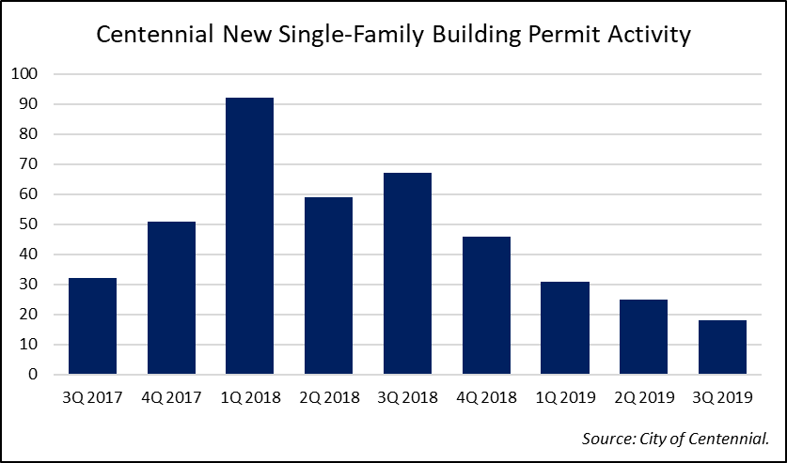Centennial reported no multi-family permits during the third quarters of 2018 and 2019.

# Commercial Real Estate

## Commercial Building Permits

* Centennial issued 102 commercial permits during the third quarter of 2019, of which all were commercial alteration permits and none were new commercial permits. This was a decrease of 14 permits compared with the third quarter of 2018 and a decrease of six permits over-the-quarter.
* Project valuation increased by 85.3 percent over-the-year due to the sharp increase in commercial alteration valuation which totaled nearly $40.9 million, an increase of 109 percent. Valuation for new commercial permits fell by $2.5 million due to no new commercial permits reported in the third quarter of 2019. In total, valuation increased by $18.8 million over-the-year.
* There was no new commercial square footage added in Centennial in the third quarter of 2019 as there were no new commercial building permits issued.

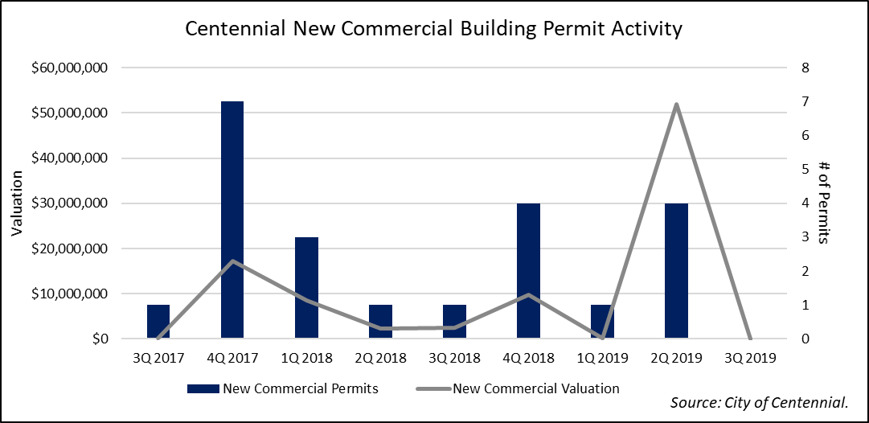

## Under Construction/Recently Completed

* There were four commercial buildings recently completed in Centennial. Building 106, an industrial building at 7151 S Blackhawk St., added 106,000 square feet of space. The second largest building completed was Crestone I at 7140 S Potomac St., an office building which added 50,000 square feet, followed by a 13,200-square-foot flex building at 6259 S Troy Cir.
* There are two commercial buildings under construction in Centennial. The largest building is an industrial building at 6281 S Racine Cir, totaling 40,000 square feet. The other building will be a “City Bark”, a veterinarian/kennel building totaling 14,327 square feet of retail space at 6840 S Kenton St.

## Office Market

* Centennial had 150 office buildings offering over 5.6 million square feet of space in the third quarter of 2019. The Southeast office market increased by 5 buildings over-the-year, while the Metro Denver office market increased by 0.5 percent, or 33 buildings, during the period.
* The office vacancy rate in Centennial increased 2 percentage points to 10.6 percent vacancy between the third quarters of 2018 and 2019. The vacancy rate increased 0.5 percentage points in the Southeast office market to 11.3 percent and decreased 0.4 percentage points to 9.1 percent in Metro Denver.
* The average lease rate in Centennial increased 6.3 percent to $23.48 per square foot over-the-year. The office lease rate in the Southeast market increased 3.7 percent, and in the Metro Denver market the lease rate increased 1.8 percent to $27.09 per square foot.
* There was negative net absorption in Centennial, falling by 61,017 square feet over-the-year. Nearly 3 million square feet of office space was absorbed in Metro Denver over the past four quarters.

## Industrial/Flex Market

* Centennial added 2 industrial and flex buildings between the third quarter of 2018 and 2019, totaling 137 buildings across 4,285,520 square feet of industrial/flex space. There was 119,200 square feet added over-the-year, an increase of 2.9 percent compared with the same time last year.
* The industrial/flex vacancy rate for Centennial decreased 0.6 percentage points over-the-year, falling to 6.4 percent. The vacancy rate increased 1.1 percentage points in the Southeast industrial/flex market and increased 0.8 percentage points in Metro Denver, rising to 5.1 percent vacancy.
* The average lease rate in the industrial/flex market in Centennial increased 4.4 percent to $10.45 per square foot. The Southeast market reported a 1.2 percent increase to $10.66 per square foot, while Metro Denver reported an increase of 6.9 percent to $9.41 per square foot over-the-year.
* There was 133,746 square feet of industrial/flex space absorbed in Centennial over the past year, while there was 4.9 million square feet absorbed in Metro Denver during the period.

## Retail Market

* Centennial had 177 retail buildings offering over 3.9 million square feet of space, representing 19.1 percent of the retail space in the Southeast market and 2.3 percent of space in Metro Denver.
* The retail vacancy rate in Centennial increased 0.5 percentage points to 5.2 percent between the third quarters of 2018 and 2019. Vacancy in the Southeast market decreased 0.3 percentage points to 3.3 percent and vacancy rose 0.3 percentage points to 4.4 percent in the Metro Denver retail market during the period.
* The average lease rate for the Centennial retail market decreased 0.6 percent to $17.82 per square foot. The Southeast market reported a 1.6 percent increase over-the-year to $20.44 per square foot, while the Metro Denver lease rate decreased 2.4 percent to $18.52 per square foot during the period.
* There was negative net absorption of retail space in Centennial of 20,136 square feet between the third quarters of 2018 and 2019. The Southeast and Metro Denver retail markets reported positive net absorption of 127,475 and 172,891 square feet, respectively.

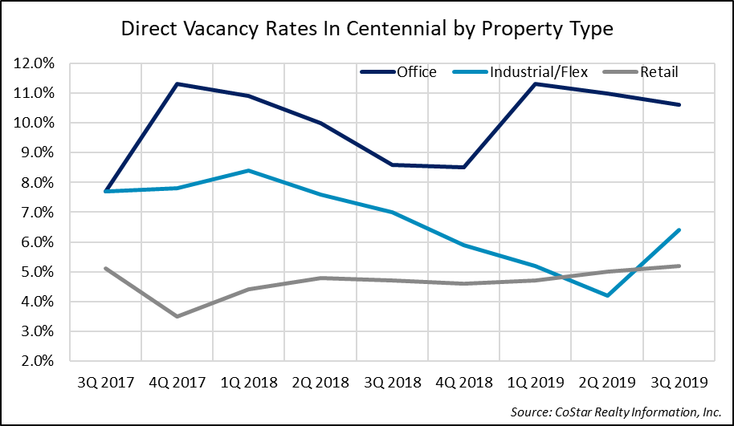

*Prepared by:*

Development Research Partners, Inc.

10184 West Belleview Ave, Ste 100

Littleton, Colorado 80127

303-991-0070

www.developmentresearch.net

October 2019

1. Metro Denver is comprised of seven-counties, consisting of Adams, Arapahoe, Boulder, Broomfield, Denver, Douglas, and Jefferson Counties.
2. A detailed list of the types of companies found within each North American Industry Classification System (NAICS) sector may be found at https://www.census.gov/cgi-bin/sssd/naics/naicsrch?chart=2017.
3. Arapahoe County-South Boundary: North: City of Englewood and City and County of Denver; East: I-25; South: Douglas County; West: City of Englewood and City of Littleton.
4. Arapahoe County-Southeast Boundary: North: Arapahoe County Line; East: Havana/Parker Road; South: Douglas County; West: I-25.